AIJA’s 58th birthday world tour challenge -Communications Toolkit
In the course of the next weeks, AIJA will be rolling out a social media campaign to share information about the upcoming AIJA 58th birthday world tour challenge. The challenge aims to raise funds for LGBTQIA+ equity, challenging everyone to complete a running, cycling, or walking activity in a team anywhere in the world, anytime between 1 to 5 July 23:59 CET; and donate to raise funds.
If you are taking part in the challenge, we would like to ask for your support to help further amplify our efforts and communicate about your participation in the challenge in your network and on your social media, with the goal to encourage others to sign up or sponsor your participation with a donation to the cause.
We have developed this toolkit to provide you with practical information, pre-drafted social media and email content for your use and/or inspiration.
Our campaign will focus on Facebook and LinkedIn. Some hashtags and emojis you can use: 🌈, 🏳️‍🌈, #weareaija, #aijaworldtour, #worldpride2020.
Practical information: links to event webpage and fundraising platform, registration form, AIJA’s social media handles and social media mobile number
Templates: ready-to-use email template, social media posts for you to distribute by email or publish straight away on your social media
Practical information
Useful links:
- Event webpage: https://www.aija.org/en/event-detail/547
- Fundraising platform: https://www.gofundme.com/aija-58th-birthday-world-tour
- Registration form: https://forms.gle/YoRz9WczJYqYfJX79
- Download visuals/ logo for social media: https://we.tl/t-vw5l9ZP4Cj
Timeline:
- 18-29 June | Registration to the challenge
- 22 June-05 July | Fundraising to support LGBTQIA+ rights
- 22-30 June | AIJA sets up and welcomes the teams in each country represented in the challenge
- 1-5 July | Participants complete the given distance (58km) in teams
Any questions?
If you would like to find out more about the challenge, how we fundraise, or what happens to your donation, please contact Pia Padfield, co-chair, AIJA Human Rights Committee (email).

Templates
Social media:
Here are three pre-drafted posts that have been developed for both Facebook and LinkedIn, should you choose to use them. By no means are you limited to this, you are welcome to adapt this or develop your own message.
When | Text | Image
During registration period  (18-29 June) | I’m taking part in the AIJA 58th birthday world tour challenge. The challenge is to complete a 58km run/walk/cycle in teams within the first five days in July, and donate in support of LGBTQIA+ equity, sign up by 29 June ➡️ https://www.aija.org/en/event-detail/547 🌈 🏳️‍🌈 #weareaija #aijaworldtour #worldpride2020 | 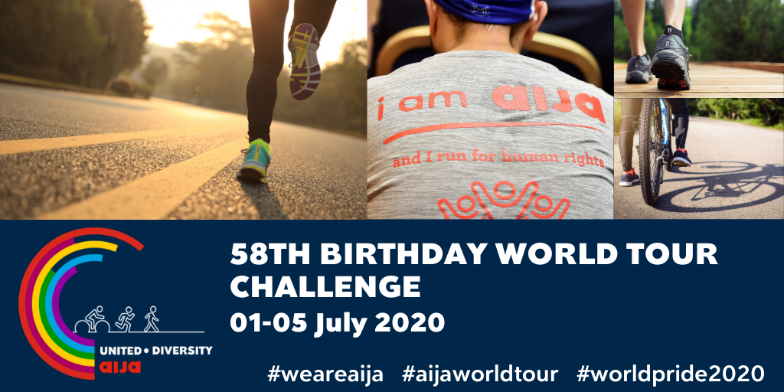
During the registration period  (18-29 June) | Support my run/walk/cycling in AIJA’s 58th anniversary challenge from 1 to 5 July by donating to support organisations that create change for LGBTQIA+ communities around the world ➡️ https://www.gofundme.com/aija-58th-birthday-world-tour 🌈 🏳️‍🌈 #weareaija #aijaworldtour #worldpride2020 | 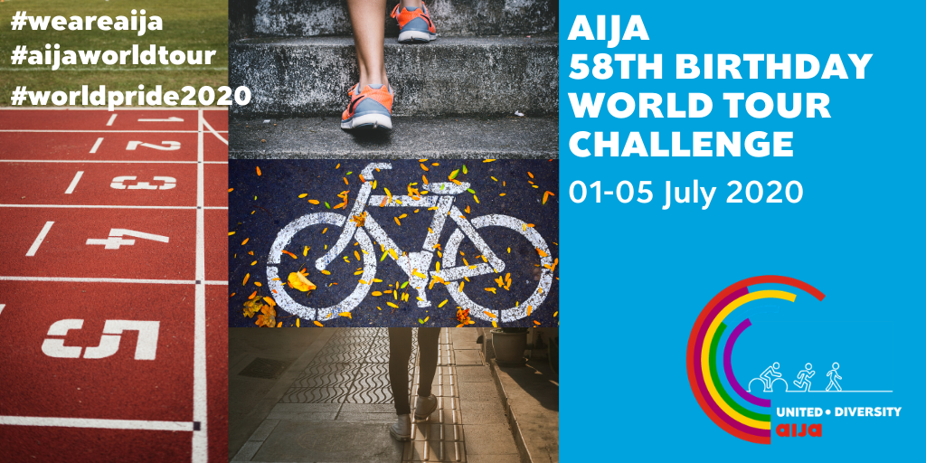
Day of your run/walk/ biking | Today, I am running/ walking/ cycling with pride in AIJA’s 58th anniversary challenge in aid of organisations that create change for LGBTQIA+ communities around the world.  Support me and the cause by donating ➡️ https://www.gofundme.com/aija-58th-birthday-world-tour  🌈 🏳️‍🌈 #weareaija #aijaworldtour #worldpride2020 | Publish a selfie or a video from your activity. An example below:  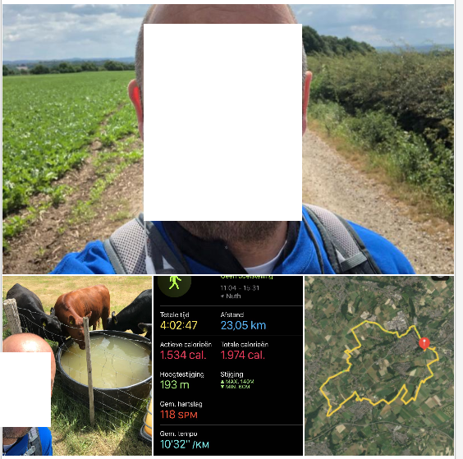

Email:
Here is a pre-drafted email that has been developed for the outreach in your network, should you choose to use it to invite fellow nationals to join the challenge. By no means are you limited to this, you are welcome to adapt this or develop your own message.
Email subject - Invitation: Join my team, AIJA’s 58th birthday challenge
Dear [insert first name],
I’m taking part in the AIJA 58th birthday world tour challenge. The challenge is to complete a 58km run/walk/cycle in teams within the first five days in July, and donate in support of LGBTQIA+ rights.
I would like to invite you to join me and complete a running, cycling, or walking activity between 1 to July 23:59 CET. The way it works is simple: you send me your mobile number and I will add you to my team’s WhatsApp group. My team represents [insert your country] in this challenge.
If you are not able to participate but you would still like to support the cause, you can donate here: https://www.gofundme.com/aija-58th-birthday-world-tour

The suggested amount is a minimum of €5. The proceeds will benefit an international charity on the frontlines around the world. In light of COVID-19, now more than ever, this needs our support. Any donation can make a big difference to the great work non-profits are doing globally and locally to support LGBTQIA+ communities. For more information about the challenge, please visit AIJA’s website: https://www.aija.org/en/event-detail/547

I look forward to teaming up for this good cause.
Kind regards,
[insert your name]

